Table of Contents
PID Information on Product Line: 2
Launch Requirements: 2
ATX Warranty Policy: 2
Manufacturing Location. Made in the USA: 4
ATX Wheels: 4
Condition of the ATX Upon Receipt: 5
ATX Latches: 5
ATX Multistage Extension Handle: 6
ATX Soft Close Handles: 7
ATX Interior Liner: 7
ATX Water Ingress: 8
ATX Weight Loading: 8
ATX Dimensions: 8
ATX Travel Damage: 9
AEGIS Warranty Policy: 9
AEGIS Repair Center Details: 11
AEGIS Wheels 11
AEGIS Multistage Extension Handle 11
AEGIS Zipper 11
AEGIS Water Resistance 11
AEGIS Weight Loading 11
AEGIS Dimensions 11

PID Information on Product Line:
- Link to travel PID( https://www.pelican.com/pid/product_list.php?product=travel )

Launch Requirements:
Pelican do not need to see return for a damaged wheel or latch. Replace the damaged components with the kits listed below.
Any other complaints or claims from 01/21/2025 through 04/01/2025 please return the case to the Warranty Department with RMA number. Pelican pay the freight. State “ATX Warranty Return” on the label.
For any claim try to capture:
  - Approximate weight inside the case?
  - Checked or carry on?
  - How many times has the product been used?
  - The approximate purchase date?
Shipping for replacement kits:
- Domestic – US based. 3-day shipping FedEx Ground is the default
- International – Offer the customer the option to ship US or International replacement parts.
  - US 3-day shipping
- International – FedEx International priority (1-3 days). If customer not happy with timing – contact Warranty Team
- If not accepted by customer - permission needed from Supervisor to ship 2 Day/Overnight/International Priority

ATX Warranty Policy:
PELICAN™ LIMITED LIFETIME GUARANTEE OF EXCELLENCE Pelican Products, Inc. guarantees its injection molded products for a lifetime against breakage or defects in workmanship. Pelican™ injection molded cases are guaranteed to be watertight to a depth of 3.3 feet (1 meter) for 30 minutes (IP 67) if properly closed with undamaged o-ring in place unless otherwise stated. To the extent permitted by law, Pelican’s liability is limited to the case and not its contents or foam. Pelican will either repair or replace any broken or defective part or case, at its sole option. TO THE EXTENT PERMITTED BY LAW, THE REMEDIES HEREBY PROVIDED SHALL BE THE EXCLUSIVE AND SOLE REMEDY OF THE PURCHASER. TO THE EXTENT PERMITTED BY LAW: (A) THIS WARRANTY IS IN LIEU OF ALL WARRANTIES, EXPRESS OR IMPLIED, INCLUDING, BUT NOT LIMITED TO, THE IMPLIED WARRANTIES OF MERCHANTABILITY AND FITNESS FOR A PARTICULAR PURPOSE; AND (B) ALL OTHER IMPLIED WARRANTIES AND ANY LIABILITY NOT BASED UPON CONTRACT ARE HERBY DISCLAIMED AND EXCLUDED. TO THE EXTENT PERMITTED BY LAW, IN NO EVENT SHALL PELICAN BE LIABLE FOR ANY INDIRECT, PUNITIVE, INCIDENTAL, CONSEQUENTIAL OR SPECIAL DAMAGES, REGARDLESS OF WHETHER A CLAIM FOR SUCH DAMAGES IS BASED ON WARRANTY, CONTRACT, NEGLIGENCE OR OTHERWISE. To the extent permitted by law, in no event shall Pelican’s liability to the purchaser for damages hereunder exceed the purchase price of the case.
ATX TRVL – COMPONENTS The ATX TRVL Case is designed and manufactured for each component to be replaced in the field by the purchaser. In addition, all components are for sale on pelican.com. All components are covered under the lifetime warranty; however, upon Pelican’s Warranty Department’s discretion, the components can be replaced by the purchaser or by Pelican’s Warranty Department. Each component can be replaced by purchaser (instructions provided) and when installed correctly, will not affect the integrity of the case (water/crush/dust proof): - 4 Spinners Wheels - TSA & NON-TSA Push Button Latches - Exterior Soft-Close Handles - Removable Interior Liner - Multi-Stage Extension Handle -Lid O-Ring Sealing Gasket To make a warranty claim, the purchaser must contact Pelican Products, Inc. at 23215 Early Avenue, Torrance, CA 90505, or at pelican.com/us/en/support/warranty/ or email csrwarranty@pelican.com, or by calling 1-800-473-5422, extension 5. Any warranty claims shall be made by the purchaser as soon as practicable. The purchaser must obtain a return authorization number from Pelican Customer Service prior to returning any case and is responsible for paying for all warranty freight costs. If Pelican determines that any returned case is not defective, within the terms of this warranty, the purchaser shall pay Pelican all costs of handling, return freight and repairs at Pelican’s prevailing rates. All warranty claims of any nature are barred if the case has been altered, damaged or in any way physically changed, or subjected to abuse, misuse, negligence or accident. Some states and countries do not allow limitations on how long an implied warranty lasts or the exclusion or limitation of incidental or consequential damages, so the above limitation or exclusion may not apply to you.

Manufacturing Location. Made in the USA:
Box States: “Designed in Torrance and made in China”. This is an error. The first production runs of the boxes were incorrectly printed. When the error was spotted the statement was covered until the new boxes arrived.
The cases are molded and assembled in Torrance, CA using US materials and foreign components.
The print on the box has been modified.

ATX Wheels:
- There are 4 unique wheels per case: A, B, C, D (see instruction sheets)
- Find out which wheel is damaged:
  - Size of the case – ATX22, ATX25, ATX30
  - Location of the wheel:
    - Picture of the case showing the damaged wheel – zoomed out
    - Describe the location (lid opening side or lid hinge side/base opening side or base hinge side)
- If the case looks as if it is damaged, then ask to send the whole case back.
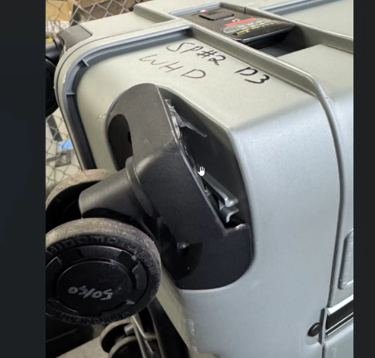
- Kits are available to ship:
  - There are 3 sizes:
    - ATX22 Kit (RPLC-WHSG4-110)
a. RPLC-WHSG4A-110
b. RPLC-WHSG4B-110
c. RPLC-WHSG4C-110
d. RPLC-WHSG4D-110

    - ATX25 Kit (RPLC-WHSG5-110)
a. RPLC-WHSG5A-110
b. RPLC-WHSG5B-110
c. RPLC-WHSG5C-110
d. RPLC-WHSG5D-110
    - ATX30 Kit (RPLC-WHSG6-110)
a. RPLC-WHSG6A-110
b. RPLC-WHSG6B-110
c. RPLC-WHSG6C-110
d. RPLC-WHSG6D-110
- Wheel does not spin freely. Case will not roll smoothly in a straight line:
  - Check that the case is not damaged around the wheel. If the whole wheel unit has been removed from the case and the case is damaged – replace the case
  - There is a gap around the damaged wheel housing. Larger than the undamaged wheel.
    - Ask the customer to remove the wheel housing and check. If the case is damaged replace the case.
    - Customer cannot remove the wheel housing – replace the wheel only and ask customer to validate that the case is not damaged when replacing wheel.
  - Wheel only damaged. Case looks intact – replace the wheel
- Wheel does not turn freely. Case will not roll smoothly in a straight line:
  - Check that the case is not damaged around the wheel. If the whole wheel unit has been removed from the case and the case is damaged – replace the case
  - Wheel only damaged. Case looks intact – replace the wheel

- Wheel cover is missing (hub cap) – wheel is still functional. Replace the wheel.
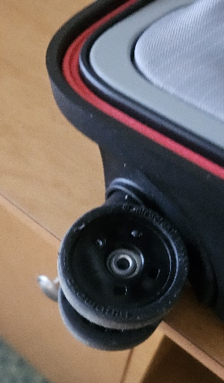

Condition of the ATX Upon Receipt:
- Box condition:
  - The first shipments did go out with a standard Pelican type box which does not protect the case against transportation damage. Actions taken to prevent this:
    - CEVA are placing all ATX cases into an over pack box to provide greater protection. This is plain brown corrugate. This will continue until a stronger box has been sourced.
    - New box has been sourced that has a thicker corrugate and bigger/flaps that make the box much stronger.
- Protective Bag:
  - Intended to protect the case during transit.
  - Dust may form on the case from transit. Wipe off with a damp cloth.

ATX Latches:
- Latch kits are available to ship:
  - There are two types of latches:
    - TSA Latch – combination lock kit (RPLC-LTCH14-110):
      - Set combination instructions (link here)
      - Cannot remember my combination – try 999 times. There is no other way of opening the latch
      - TSA key – not available
      - DO NOT FORCE THE LATCH as it will damage the case & void warranty.
      - Latch wobbles/feels loose – gently tighten the screws on the latch (see installation instructions)
      - Latch will not close – replace the latch
      - Latch damaged/cracked – verify that the case is not damaged, around the screws holding the latch in place and replace the latch (see instructions)
      - Latch damaged & case around the area damaged not allowing the latch to close – replace the case

    - Standard Latch kit (ATX25 & ATX30) (RPLC-LTCH15-110)
      - Latch will not close – replace the latch
      - Latch wobbles/feels loose – gently tighten the screws on the latch (see installation instructions)
      - Latch damaged – verify that the case is not damaged, around the screws holding the latch in place and replace the latch (see instructions)
      - Latch damaged & case damaged around the area not allowing the latch to close – replace the case

ATX Multistage Extension Handle:
- There are three unique sizes:
- ATX22 Kit (RPLC-EXTH1-110)
- ATX25 Kit (RPLC-EXTH2-110)
- ATX30 Kit (RPLC-EXTH3-110)
- Handle drops without pressing the release button – replace the handle
- Release button will not work – replace the handle
- Handle bent/will not collapse:
  - If impacting travel – handle can be removed
  - Check that the case is not damaged around the screws and attachment bars – if damaged replace the case
  - If case not damaged replace the extension handle
- Plastic housing cracked/broken - replace the handle

ATX Soft Close Handles:
- There is one size (RPLC-HNDL16-110)
- Replacement Kit (RPLC-HNDL16-110)
- Handle will not self-close – replace the handle
- Handle broken:
  - Verify that the case is not damaged, around the screws holding the handle in place and replace the handle (see instructions)
  - If the case is damaged around the handle screws holding the handle in place – replace the case

ATX Interior Liner:
- There are 3 sizes. Each size has a lid and base:
  - ATX22 Lid Kit (RPLC-LINR1L-CGRY)
  - ATX22 Base Kit (RPLC-LINR1B-CGRY)
  - ATX25 Lid Kit (RPLC-LINR2L-CGRY)
  - ATX25 Base Kit (RPLC-LINR2B-CGRY)
  - ATX30 Lid Kit (RPLC-LINR3L-CGRY)
  - ATX30 Base Kit (RPLC-LINR3B-CGRY)
- Zipper is stuck/does not work – replace the liner (see instructions)
- Frame has moved:
  - Check that the frame is not damaged – pop the liner back into position
  - If the frame is damaged – replace the liner
  - If the case & frame is damaged – replace the case
- Liner is stained – clean options or customer can purchase a replacement
- Liner has pulled away from the plastic frame – replace the liner

ATX Water Ingress:
- Cases are watertight (IP rating)
- Case leaked:
  - Capture the conditions that the case was exposed to – rain, submersed
  - Ask about the loading of the case ensure that it was evenly packed and can be closed easily – very important for the sealing
  - Ensure that the gasket and liner are clean and no presence of dirt – clean or customer can purchase a replacement
  - Ensure that all latches can close correctly – that are important to seal the case – latch broken – see above
  - If all above do not apply, then send the case back to Torrance for attention of QA Manager and replace the customer's case

ATX Weight Loading:
- Cases are designed to comply with the carry-on limits for US airlines:
  - ATX22 – Carry on up to 40 lbs
  - ATX25 – Check in up to 50 lbs
  - ATX30 – Check in up to 70 lbs

ATX Dimensions:
- Cases are designed around the standard US airline restrictions:
  - ATX HC22 (18.6” X 11.78” X 7.24”)
  - ATX HC25 (22.00” X 15.70” X 8.72”)
  - ATX HC30 (25.97” X 17.63” X 10.21”)

ATX Travel Damage:
- Case is discolored/damaged from use. The pigments used in some colors can separate when placed under stress. This appears as a white mark in the resin. The case is not defective and will continue to provide the protection that it was designed to provide.

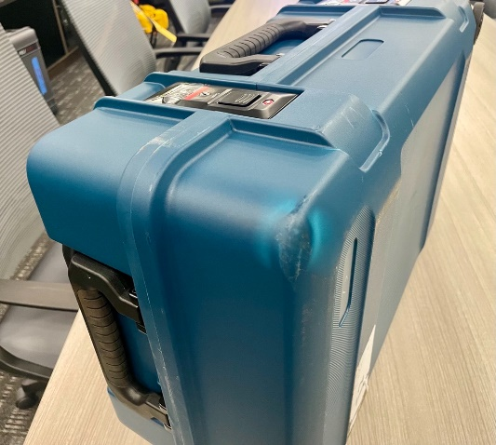 | 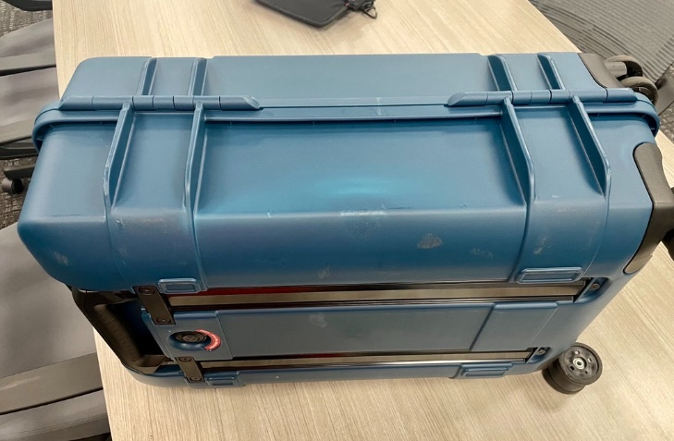

AEGIS Travel Line

PID Information on Product Line:
- Link to travel PID( https://www.pelican.com/pid/product_list.php?product=travel )

AEGIS Warranty Policy:
LIMITED 5-YEAR WARRANTY
All Pelican TRVL™ Hybrid Products (Rolling Duffels, Backpacks, Bags and Modpak™ accessories) have a limited 5-year against manufactured defects and failures which cause the case to become non-functional.
Upon Pelican’s warranty department’s discretion and based on use / claim, Pelican will either repair the product, replace (with same or similar product) or refund.
Our limited warranty does not cover:
    - Cosmetic scuffs, scratches, stains, or normal wear & tear
    - Use-case failure, misuse, neglect, or intentional damage
    - Non-Pelican / Peli products
Through our repair center, we will repair/replace at our discretion. To the extent permitted by law, Pelican’s liability is limited to the Pelican Hybrid Product and not its contents or foam and in no event shall Pelican’s liability to the purchaser for damages exceed the purchase price of the Pelican Hybrid Product in respect of which damages are claimed.
TO THE EXTENT PERMITTED BY LAW: (A) THIS WARRANTY IS IN LIEU OF ALL WARRANTIES, EXPRESS OR IMPLIED, INCLUDING, BUT NOT LIMITED TO, THE IMPLIED WARRANTIES OF MERCHANTABILITY AND FITNESS FOR A PARTICULAR PURPOSE; (B) ALL OTHER IMPLIED WARRANTIES AND ANY LIABILITY NOT BASED UPON CONTRACT ARE HEREBY DISCLAIMED AND EXCLUDED; AND (C) IN NO EVENT SHALL PELICAN BE LIABLE FOR ANY INDIRECT, PUNITIVE, INCIDENTAL OR CONSEQUENTIAL DAMAGES, OR SPECIAL DAMAGES, REGARDLESS OF WHETHER A CLAIM FOR SUCH DAMAGES IS BASED ON WARRANTY, CONTRACT, NEGLIGENCE OR OTHERWISE.
Pelican will either repair or replace any defective product at our sole option. Certain products are available for a limited time only. If a claim is made involving one of these products, Pelican reserves the right to replace a broken or defective product with a standard Pelican product of comparable size and quality if no comparable limited-edition product is available at the time of a claim. TO THE EXTENT PERMITTED BY LAW, THIS SHALL BE THE SOLE AND EXCLUSIVE REMEDY OF THE PURCHASER. Any repaired or replacement part or fabric portion of the Pelican Hybrid Product is covered only for the unexpired portion of the warranty on the original product purchased. To make a warranty claim, the purchaser must complete the warranty claim form at pelican.com/claim. Any warranty claims shall be made by the purchaser as soon as practicable and in no event more than one year from the date of purchase where the warranty claim relates to the fabric Pelican Hybrid Product. Claims relating to these products also require a valid dated proof of purchase. The purchaser must obtain a return authorization number from Pelican Customer Service prior to returning any product and is responsible for paying for all warranty freight costs. If Pelican determines that any returned product is not defective, within the terms of this warranty, the purchaser shall pay Pelican all costs of handling, return freight and repairs at Pelican’s prevailing rates.
All warranty claims of any nature are barred if the product has been altered, damaged or in any way physically changed, or subjected to abuse, misuse, negligence or accident.
Some states and countries do not allow the exclusion or limitation of incidental or consequential damages, so the above limitation or exclusion may not apply to you. This warranty gives you specific legal rights, and you may have other rights which vary from state to state and country to country.

AEGIS Repair/Replace Details:
1. After 90 days from the product launch date, any warranty-related issues if not covered use:
2. Contact:
- Email: Tony.Liddell@Pelican.com
- Phone: 310-326-4700 ext. 1488

AEGIS Wheels
- Wheels damaged – replace the case
- Wheel Kit (not available yet)

AEGIS Multistage Extension Handle
- Handle damaged/broken – replace the case

AEGIS Corner Protectors
4. Corner missing – Replace the case

AEGIS Zipper
- Zipper derailed/separated/stuck and will not operate:
  - If the rest of the bag is not damaged - Send to repair Pelican repair center:
    - Address & contact – RMA to be provided
  - If the bag is damaged – replace the bag under warranty

